QI Basics

The Model for Improvement and
PDSA Worksheet

The Model for Improvement and Plan-Do-Study-Act (PDSA) Worksheet helps teams to plan, conduct, analyze, and monitor progress of a quality improvement (QI) effort with tests of change to help meet the aim or goal.

Adapted from: Langley GL, Moen R, Nolan KM, Nolan TW, Norman CL, Provost LP. The Improvement Guide: A Practice Approach to Enhancing Organizational Performance. San Francisco, California, USA: Jossey-Bass Publishers, 2009.

Introduction
The questions in the Model for Improvement help a team to clearly state what they are trying to accomplish, develop measures to determine whether improvement has been made, and identify interventions to achieve improvement. This prepares the team to test a change or changes using Plan-Do-Study-Act (PDSA) cycles by planning it, trying it, observing and studying the results, and acting on what is learned.

How to Use
The quality improvement project team should complete this tool.
- Answer the first two questions in the Model for Improvement (overall project aim and measure). Look back to your Charter to help inform the answer to question one.
- Examine and document the processes currently in place, using process-mapping.
- Identify potential opportunities for improvement. These could be:
  - Points where breakdowns occur
  - Workarounds
  - Variations in workflow
  - Duplicate or unnecessary steps
- Use QI tools and methods to understand the root causes of problems identified (e.g., five-whys, cause and effect diagram).
- Decide what you will change in the process based on your analysis by answering the third question of the Model for Improvement. Change ideas could stem from:
  - Identifying better ways to do things that address the root cause of the problem
  - Learning and copying what has worked at other organizations
  - Reviewing the best available evidence for what works (literature, studies, guidelines, etc.)

- Document the plan for change in the PDSA worksheet:
  - Plan: What exactly do you plan to do? What is your intervention? What exactly are you going to measure to evaluate the success of the test of change?
  - Do: Carry out the test of change. Document what happened, collect data. Note any differences between the plan and implementation. Note any surprises or challenges.
  - Study: Analyze the results. Summarize and reflect on what you learned; this will help you determine next steps.
  - Act: Determine what next steps will be. Will you:
    - Adapt – modify the changes and conduct another PDSA cycle.
    - Adopt – expand changes in the organization to additional patients, staff, units, etc.
    - Abandon – don’t do another test on this change idea; consider other approaches and start a new cycle.

Remember, the solution doesn’t have to be perfect the first time. A QI project will usually involve multiple PDSA cycles to achieve your aim. Use as many forms as you need to track your PDSA cycles. This will help you build sequential knowledge and support further improvement.

An example PDSA Worksheet is provided at the end of this document for your reference.

The Model for Improvement: Three Questions

- What are we trying to accomplish (aim)?

- How will we know that change is an improvement (measures)?

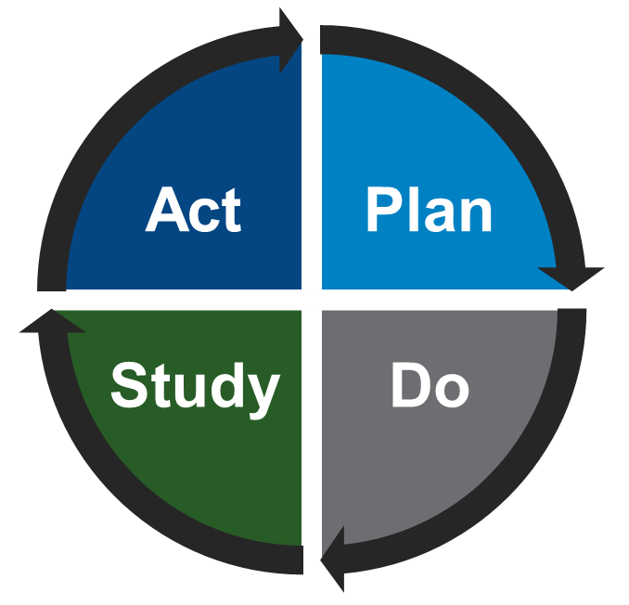
- What change can we make that will result in an improvement
Carry out the test of change and collect data.
What exactly are we going to do?
What are next steps based on our findings?
What were the results? What did we learn?

Plan-Do-Study-Act Worksheet

Plan – What exactly are we going to do? (Add rows to table below as needed.)
Describe test of change | Person responsible | When to be done | Where to be done | Other notes

Plan – What exactly are we going to measure to evaluate the test of change? (Add rows to table below as needed.)
Measure | Baseline (if known) | Prediction | Outcome/Result (to be populated after the ‘Do’ phase)

Do – Carry out the test of change and collect data. (Add rows to table below as needed.)
Was the change implemented as expected? Note any deviations from Plan. | What happened? Surprises? Challenges?

Study – What were the results?
Populate the result of your PDSA cycle measure(s) in the outcome column in the Plan section above, Analyze the results from both your quantitative and qualitative measures. Summarize and reflect on what you learned; this can be help you determine next steps.

Act – Should we adapt, adopt, or abandon the change? Prepare a ‘Plan’ for the next PDSA.

☐ Adapt – modify the changes and conduct another PDSA cycle. What will change in the next test?
☐ Adopt – expand changes in the organization to additional patients, staff, units, etc. How will the test be expanded in the next cycle?
☐ Abandon – don’t do another test on this change idea. Consider other approaches and start a new cycle.

Describe what modifications to the plan will be made for the next cycle based on what you learned:

Example Plan-Do-Study-Act Worksheet
The example below is based on a clinic that is seeking to improve the identification and treatment of its patients that have hypertension. The clinic will attempt several small-scale interventions/improvements to raise their performance on this measure.

The Model for Improvement: Three Questions

- What are we trying to accomplish (aim)?
We are trying to improve our NQF 0018 measure and improve our clinic’s ability to properly identify and diagnose patients with hypertension. We believe that we are doing well with the treatment portion of our measure and we will not focus on this as part of our PDSA cycle of improvements.
- How will we know that change is an improvement (measures)?
Improvement in performance on the National Quality Foundation 0018 measure: Controlling High Blood Pressure - increase the % of patients 18-85 years of age who had a diagnosis of hypertension and whose blood pressure was adequately controlled (<140/90) during the measurement year. Our goal will be to improve our facilities current performance rate from 45% to 55% within 1 month starting the first day next month.
- What change can we make that will result in an improvement?
Our team working on this topic identified areas for opportunity based on our processing mapping, and has identified updates to our workflow to test. We will start to test the new workflow with one provider/nurse team for one month. Changes will include a higher level of accuracy when taking blood pressures (BPs) based on American Heart Association guidelines and best practices, along with a focus on improving the accuracy of documenting them in the EHR (getting hypertension on the problem list and entering BPs consistently in the same fields (not in the notes field, for example).

Plan – What exactly are we going to do? (Add rows to table below as needed.)
Describe test of change | Person responsible | When to be done | Where to be done | Other notes
QI Team leader to present and emphasize importance of proper BP checking techniques and documentation | Team Leader | At next provider meeting | Provider meeting at the clinic
Physician (MD)/Medical assistant (MA) teams will utilize the updated blood pressure workflow which will include a higher level of accuracy and documenting BPs in the EHR | MD/MA teams | Monday-Friday during the month of xxx.  MM/DD/YYYY-MM/DD/YYYY | Clinic with all patients seen by MD/MA teams | MAs will be responsible for double-checking that the process was followed and noting any deviations from workflow

Plan – What exactly are we going to measure to evaluate the test of change? (Add rows to table below as needed.)
Measurement | Baseline (if known) | Prediction | Outcome/Result (to be populated after the ‘Do’ phase)
NQF 0018 Hypertension | 45% | 55% | 62%
Number of patients with two or more BP values of greater than 140/90 who don’t have hypertension as a diagnosis in the problem list in the EHR | Unknown | Unknown, but should be close to 0% (inverse measure, lower is better) | To be determined

Do – When and how did we do it?
Was the change implemented as expected? Note any deviations from Plan. | What happened? Surprises? Challenges?
There were some challenges the first few days in remembering the standardized process to document BPs in the EHR (challenge in altering documentation behavior) and finding the correct spots in the EHR, but once the team was on the same page and the EHR bugs were worked out, the process went smoothly | Over the initial test cycle, BPs were getting documented correctly, and there were fewer questions after the first few days. All providers improved their documentation and utilized the correct fields in the EHR for systolic and diastolic blood pressure readings. Clinicians were making sure the proper BP check techniques were consistently done and recorded (which they provided as feedback in a provider/staff meeting). New HTN diagnoses were recorded in the problem list with the exception of one provider. Follow up training is being done with this provider.

Study – What were the results?
Populate the outcome column in the Plan section above and analyze the results. Summarize and reflect on what you learned, particularly as it can be help you determine next steps.
Overall, the test was very successful. We saw a 15% increase in patients diagnosed with hypertension (NQF 0018) who also had their diagnosis under control and the team was able to follow the updated workflow consistently.
- Week 1: 47% at end of week
- Week 2: 54% at end of week (*close to 55% goal after 2 weeks)
- Week 3: 58% at end of week
- Week 4: 62% at end of month (& 1-month test period) (*exceeded 55% goal at end of test period)
- The biggest issue with the EHR was addressed during this test, which was and clinician knowledge about how are where to document BP readings and confirming the diagnosis in the problem list. We learned that by implementing xxx, staff and clinicians were successful in documenting BP readings and confirming the diagnosis in the problem list. We expect that this success can be spread throughout the clinic.
- The clinic data analyst and super user was able to determine that our clinic had 24% of our population with elevated BPs (greater than 140/90) without a hypertension diagnosis in their problem list. Cleanup work was done with providers and we got this down to 7% (fewer is better) after the 1-month test. We expect that this will go below 2 or 3% now that providers are getting the documentation done correctly.

Act – Should we adapt, adopt, or abandon the change? Prepare a ‘Plan’ for the next PDSA.

☐ Adapt – modify the changes and conduct another PDSA cycle. What will change in the next test?
☒ Adopt – expand changes in the organization to additional patients, staff, units, etc. How will the test be expanded in the next cycle?
  - Continue testing next week with additional MD/MA teams, to keep learning and testing under different conditions
☐ Abandon – don’t do another test on this change idea. Consider other approaches and start a new cycle

Describe what modifications to the plan will be made for the next cycle based on what you learned:

We expect that we can improve the NQF0018 metric by continuing education and ongoing training, making the new procedures part of our new hire process and recurrent annual training. Given that we have experienced success in our first round of PDSA testing, we will discuss spreading these successes to other locations beyond our initial set of MDs and MAs. We will do additional PDSA test cycles and NQF0018 data pulls to confirm effectiveness.

