QI Basics

PICK Prioritization Matrix

The QI PICK (Possible – Implement – Challenge – Kill) Prioritization Matrix is a Lean Six Sigma tool to help prioritize work that your quality improvement (QI) team should undertake using a quadrant system that corresponds to the “PICK” acronym. It will help you to prioritize multiple project options by considering and comparing the payoff and difficulty of implementing each one.

Introduction
The PICK prioritization matrix helps your team take a diverse set of opportunities for improvement or project ideas and prioritize them based on team discussions. This tool and prioritization method can prevent choosing an opportunity based on individual preference or on the views of the person who can mount the most convincing argument. It is also helpful as a future reference if the team wants to look back and see why they chose a certain opportunity over others.

One of the most valuable aspects of a prioritization matrix is that it creates a platform for people to actually discuss the pros and cons of each opportunity and may encourage the team to work on something very important, but may have been initially passed over because it appeared to challenging. It also prevents teams from feeling like they have to work on a project that fits with "the flavor of the day" or what everyone else is working on in their industry or setting.

How to Use
The project team should complete this tool. Whenever possible, it’s ideal to do this as an in-person meeting or to have video conferencing available so that all participants can see the matrix and the projects that are assigned to quadrants as your conversation progresses.
The first step is to list out all possible projects or improvement ideas in the first column of the PICK Prioritization List. Restrict the list as needed according to some level of scope or constraint that is specific to your organization’s quality goals. For the purposes of the PICK matrix, we suggest limiting the total projects to no more than 12.

Note – This tool and process can be used at various times throughout quality improvement initiatives. A leadership team could use this to help determine which projects to pursue, and a QI team could, for example, use it to determine which improvement ideas to implement within a given project.

Next, draw the PICK matrix as shown below. If possible, the best approach is to use a whiteboard or flip-chart.
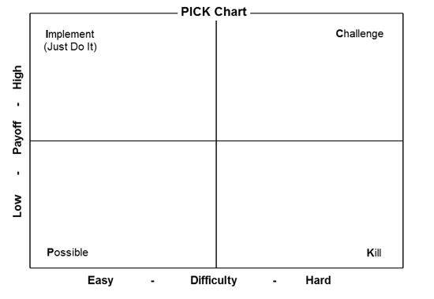
Write the name of the project idea on a sticky note which you included on the PICK Prioritization List. This tool works best if you limit yourself to a dozen or so possible projects. You can include more, but be aware that it takes time to discuss each project and answer the questions below to confirm where the project should be positioned on the matrix.

Through discussion with the team, determine which quadrant each project belongs in, considering the difficulty of implementing (easy to hard along the bottom) and the level of payoff (low to high along the side). Some factors to consider during this discussion include cost, time, staff availability, staff buy-in, leadership support, alignment with strategic goals, patient outcomes, patient satisfaction, available data, and sustainability. Your team may identify other factors to consider.

As you discuss each project, populate the additional columns of the Pick Prioritization List with the following information:
- Difficulty: Did the team determine this project/improvement activity would be easy or hard to implement?
- Payoff: Did the team determine this project/improvement activity would yield low or high payoff?
- PICK Quadrant: In which of the four quadrants (Possible, Implement, Challenge, Kill) was the project/improvement activity positioned?
- Project Owner: If the project/improvement activity has a specific owner (individual, role, department, etc.) enter that. There could be multiple owners or a team, or other groups could be the owners.

- Final Ranking: This column is left blank until a final ranking has been accomplished and the projects/improvement activities identified for work are agreed on by your QI team.
- Notes/Comments: Any ancillary notes, descriptions, comments, etc. can be entered here. You may wish your note taker to document answers to the questions below either here or on a separate sheet to retain a record of the major pros and cons, and why each project/improvement activity was placed in a certain quadrant on the PICK matrix.

The PICK Prioritization Matrix will typically yield 2-3 opportunities that stand out as the highest priorities in either the Implement or Challenge quadrants. Additional factors that are unique to each project will need to be taken into consideration to determine which one to choose first.
The questions below are for the team to consider in making that final choice.
- Are there existing standards or guidelines that can help with this initiative?
- Are there measures available to help monitor progress or would we have to create them?
- Is this a topic that is publicly reported and therefore important to our organizations image?
- What type of changes will be involved, what staff will be most effective, and what training needs will be needed?
- Do we have any champions for this initiative or anyone who has passion for the topic?
- If we do work in this area will it have an impact in any other way in our organization?

An example QI PICK Prioritization List is provided at the end of this document for your reference.

PICK Prioritization List of Possible Projects/Improvement Activities

Project Idea | Difficulty  (Easy or Hard) | Payoff  (Low or High) | PICK  Quadrant | Project Owner | Notes/Comments

Example PICK Prioritization List

Project Idea | Difficulty  (Easy or Hard) | Payoff  (Low or High) | PICK  Quadrant | Project Owner | Notes/Comments
Hypertension – diagnosis and treatment improvement | Easy | High | Implement | Dr. Jane Polinski | Aligns with organizational priorities
Hand hygiene monitoring | Easy | Low | Possible | TBD | Time intensive, unsure of need
Develop Patient Advisory Council | Hard | High | Challenge | TBD | We know this is important, but it will also be highly time intensive; need to ensure resources are dedicated before launching.
Conduct 24-hour follow-up calls with all patients presenting with cold symptoms | Hard | Low | Kill | NA

