Name__________________________

Dept. __________________________

2017 Quality
Scavenger Hunt

Rules: Answer all of the questions below. Hint: You must know where to look to find the answers. Turn your completed forms into Brenda Stevenson by the morning of October 23rd. All correctly completed entries will be entered into a prize drawing. Good Luck!!

- What is our overall core measure rating for second quarter 2017?

- Who was on the first 2017 Flu poster and what were they doing?

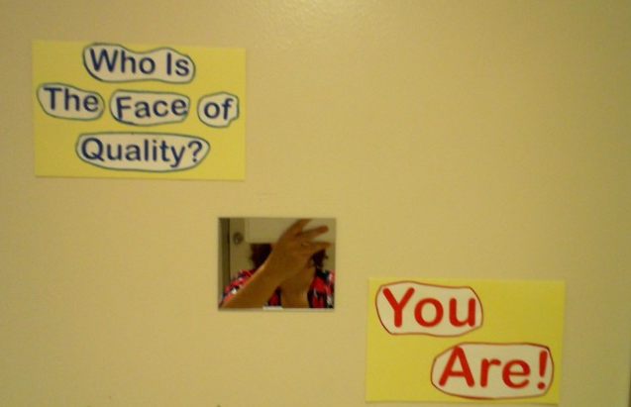
- Where can you find this?

- What is the name of the quality newsletter?

- Who signed our Quality Assessment and Process Improvement Plan?

- Where is the Quality Department (Director’s Office)?

