SCH Secret Pen Pal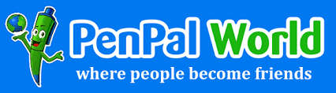
Get to know people from all around Sparrow Clinton Hospital in a new and innovative way.
Voted on in NQEC to roll this out hospital wide, only to those who wish to participate. This will last 12 weeks. Each week you will send and anonymous tip, info, thought, something personal about yourself to the name that you draw. Keeping it anonymous. Make it as fun and creative as you wish. At the end of the 12 weeks each person who participates will get an opportunity to guess their new pal. Hopefully this will be done in one of the conference rooms. If you wish to participate, please sign up. Working toward a more unified workplace where we all know each other a little better. The signup sheet will be collected Monday June 28.

