SMART Goals Worksheet
Goal setting is essential for any performance improvement. It helps clarify your purpose, design your impact measurement, and focus your action planning. Goals should clearly describe what the organization or team intends to accomplish and address questions such as, “Is this goal leaving anyone out?” or “If this goal is successful, will there be any unintended consequences?” Use this worksheet to establish a goal by following
the SMART formula outlined below.

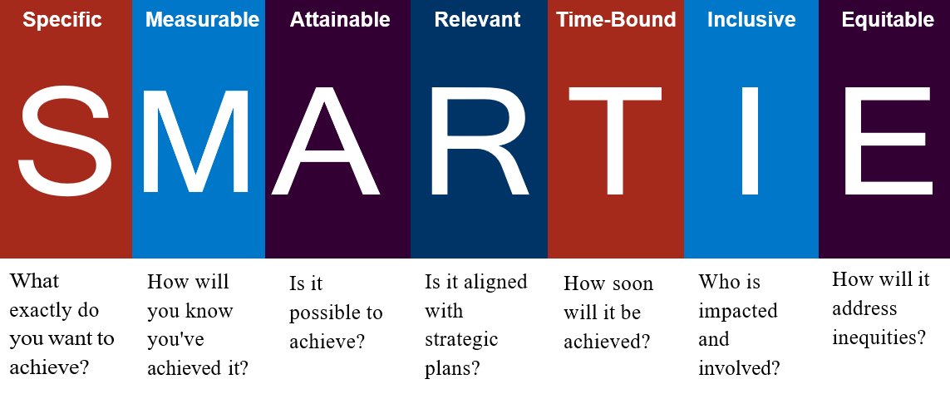

Here’s an example of a goal turned into a SMART goal:
Good  Goal | Better  SMART Goal(s)
We will reduce hospital-acquired infections. | Example 1: We will reduce hospital-acquired CAUTI infections by 25% by December 2026.  Example 2: We will reduce hospital-acquired CAUTI infections by 25% among women 65 years and older by December 2026 (if your facility has noted that rates are higher in older women).

Writing Your SMART Goal
Use the following spaces to help you brainstorm and refine a SMART goal.
What Specific strategic outcome are you trying to achieve? What problem or challenge will it solve? Is there a specific population or group of patients you are focusing on?

What Measure(s) will you use? What data source(s) you will use? How and when will you know the project has been successful and/or is complete? How will you stratify data to check for current differences across populations or groups?

What is your ambitious yet Attainable benchmark(s)? Is it impossible or unreasonable to attain and maintain? Is it set too low and not challenging enough? Are the right individuals or partners involved to ensure the goal can be achieved?

How is this goal Relevant and related to our overall strategic improvement plan or current improvement priorities? Is this goal realistic, given our current resources?

Time-Bound: The timeline for this project is between (start date) through (end date)

