QI Basics

Force Field Analysis

The QI Force Field Analysis tool helps you identify, document, and analyze “forces” that are driving or restraining change.
Adapted from: Lewin, K. (1951). Field theory in social science. London: Tavistock Publications Ltd.

Introduction
Quality expert Kurt Lewin developed the Force Field Analysis. It aims to help you make decisions by analyzing the forces for or against a change (desired improvement goal). In this graphic, you can see the line in the center representing our current state, and the big blue arrow in the background is the direction we want to move to achieve our improvement goal on the right. In the middle, we have our driving and restraining forces - those factors that are helping to facilitate or hinder the change needed to achieve our goal. Force field analysis encourages us to consider those factors and how they are at odds with each other.

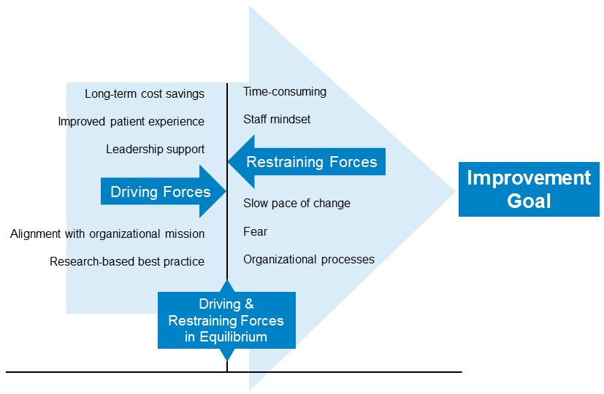

How to Use
This tool is intended to be completed as a team, incorporating the expertise of all members.

- Identify Driving and Restraining Forces: List the significant factors the team is aware of that would impact the specific change being considered, separating them into lists of driving and restraining forces. If something could be viewed as both driving and restraining, note it on both lists. Below is a list of common forces, but do not limit yourself to this list. The team should discuss and brainstorm forces relevant to your work.

  - Available resources
  - Attitudes of people
  - Mission and/or values
  - Traditions
  - Regulations
  - Desires
  - Vested interests
  - Personal or group needs
  - Time needed
  - Patient experience
  - Costs/finances
  - Organizational structures & processes
  - Present or past practices
  - People
  - Relationships
  - Institutional policies or norms (culture)
  - Scheduling and events
  - Social or organizational trends
  - Pace of change

Note – the team should not limit themselves to the spaces provided in the template. Add rows to the Force Field Table as needed to capture all contributing factors for consideration.
- Determine Impact: Assign the level of impact for each factor as high, medium, or low. Once all factors are named, sorting them from high to low on each list may be useful.
- Gather Notes/Comments: Any ancillary notes, descriptions, comments, etc., can be entered here, including ideas around how to address restraining forces or enhance driving factors.
Once the Force Field Table is populated, the team can determine what work is necessary to address the restraining forces and enhance the driving forces. Often, the default is to focus on increasing driving forces to achieve change, but potentially more important is considering how we can reduce restraining forces hindering change.

An example QI Force Field Table is provided at the end of this document for your reference

Example Force Field Table

Change Proposal: Describe the change you are proposing to make.

Driving Forces | Restraining Forces | Impact (High/Med/Low) | Notes / Comments
Peer clinics that are performing higher than ours |  | Med | Keep abreast of published NQF0018 peer performance
Project sponsor who is motivated to improve our measure |  | High | Tap into the project sponsor skills and knowledge as needed to keep things moving forward
Improved analytics capability in our EHR |  | Med | Pull our measure numbers for frequency
Clinic has also chosen this measure for the CMS QPP/MIPS reporting program |  | High | Clinic leadership is looking at this measure more closely including for financial implications
 | Clinic has been slow to make QI changes in the past | Med | Keep in mind when developing PDSA plans and be strategic about engaging frontline staff
 | Although we have improved EHR analytics, not all staff know how to use them | High | Confirm training and ability to analyze and display data meaningfully
 | Lack of time for QI team meetings and taking staff away from patient care | High | Need to have conversations with clinic leadership to secure needed resources
 | Some clinicians distrust the data (believe they do high quality work so the measure or data must be wrong) | Med | Discuss project at clinician meetings ongoing to support shared learning and understanding

Force Field Table

Change Proposal: Describe the change you are proposing to make.

Driving Forces | Restraining Forces | Impact (High/Med/Low) | Notes / Comments

