QI Basics

The Model for Improvement
and PDSA Worksheet

The Model for Improvement and Plan-Do-Study-Act (PDSA) Worksheet helps teams plan, conduct, analyze, and monitor the progress of a quality improvement (QI) effort with tests of change to meet the aim or goal.

Adapted from: Langley GL, Moen R, Nolan KM, Nolan TW, Norman CL, Provost LP. The Improvement Guide: A Practice Approach to Enhancing Organizational Performance. San Francisco, California, USA: Jossey-Bass Publishers, 2009.

Introduction
The questions in the Model for Improvement help a team clearly state what they are trying to accomplish, develop measures to determine whether improvement has been made, and identify interventions. This prepares the team to test a change or changes using iterative Plan-Do-Study-Act (PDSA) cycles by planning a change, doing or trying the change, observing and studying the results, and acting on what is learned.

The Model for Improvement: Three Questions

What are we trying to accomplish (aim)?

How will we know that change is an improvement (measures)?

What change can we make that will result in an improvement?

Changes are then tested using iterative PDSA cycles.
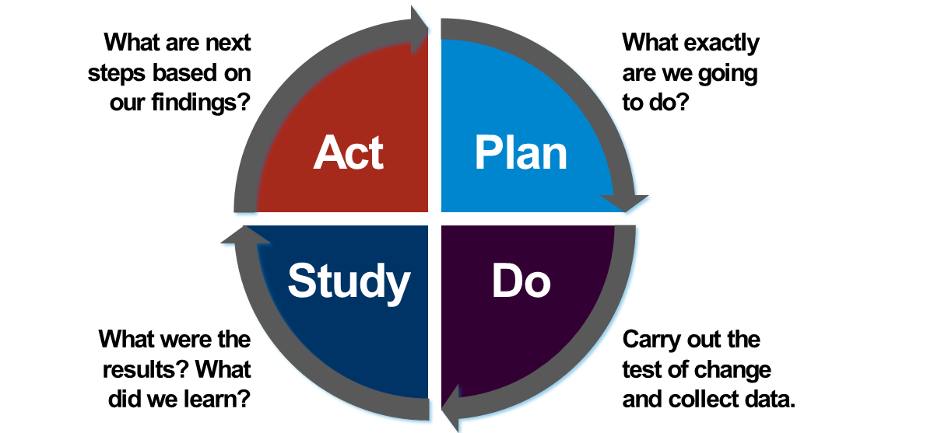

How to Use
The quality improvement project team should complete this tool.
- Answer the first two questions in the Model for Improvement:
  - What is your overall project aim? (Look back to your Charter)
  - How will you measure improvement on your overall project Aim to know if change(s) are an improvement?
- Examine, understand, and document the processes currently in place, such as process mapping.
  - Use QI tools and methods to understand the root causes of problems identified (e.g., five-whys, cause and effect diagram (sometimes called fishbone diagram), root cause analysis).
- Identify potential opportunities for improvement. These could be:
  - Points where process breakdowns occur.
  - Workarounds
  - Variations in workflow
  - Duplicate or unnecessary steps
- Decide what you will change in the process based on your analysis by answering the third question of the Model for Improvement: What change can we make that will result in an improvement? Change ideas could stem from the following:
  - Reviewing the best available evidence for what works (literature, studies, guidelines, etc.)
  - Identifying better ways to do things that address the root cause of the problem.
  - Learning and copying what has worked at other organizations.
- Document the plan for change in the PDSA worksheet:
  - Pla n: What exactly do you plan to do? What is your intervention? What exactly are you going to measure to evaluate the success of the test of change?
  - Do: Carry out the test of change. Document what happened and collect data. Note any differences between the plan and implementation. Note any surprises or challenges.
  - Study: Analyze the results. Summarize and reflect on what you learned; this will help you determine the next steps.
  - Act: Determine what the next steps will be. Will you:
    - Adapt – modify the changes and conduct another PDSA cycle.
    - Adopt – expand organizational changes to additional patients, staff, units, etc.
    - Abandon – don’t do another test on this change idea; consider other approaches and start a new cycle.

Remember, the solution doesn’t have to be perfect the first time. A QI project involves multiple, iterative PDSA cycles to achieve your aim, as you start testing the change on a smaller scale, with only a few staff members or clinicians and then expand to test solutions with additional staff and in a wider variety of conditions (different days, shifts, etc.). Adapt the changes/solutions as needed as you learn from each PDSA cycle. Use as many forms as you need to track your PDSA cycles. This will help you build sequential knowledge and support further improvement.

Worksheet: The Model for Improvement: Three Questions

What are we trying to accomplish (aim)?

How will we know that change is an improvement (measures)?

What change can we make that will result in an improvement?

Plan  - What change are you testing with the  PDSA cycle(s)?  - What do you predict will happen and why?  - Who will be involved in this PDSA? (e.g., one staff member or resident, one shift?). Whenever feasible, it will be helpful to involve direct care staff.  - Plan a small test of change.  - How long will the change take to implement?  - What resources will  they need?  - What data needs to be collected? | List your action steps, the person(s) responsible, and the timeline.
Do  - Carry out the test on a small scale.  - Document observations, including any problems and unexpected findings.  - Collect data you identified as needed during the  “plan” stage. | Describe what actually happened when you ran the test.

Study  - Study and analyze  the data.  - Determine if the change resulted in the expected outcome.  - Were there implementation lessons?  - Summarize what was learned. Look for unintended consequences, surprises, successes, and failures. | Describe the measured results and how they compared to the predictions.
Act  Based on what was learned from the test:  - Adapt – modify the  changes and repeat the PDSA cycle.  - Adopt – consider expanding the changes in your organization to additional residents, staff, and units.  - Abandon – change your approach and repeat the PDSA cycle. | Describe what modifications to the plan will be made for the next cycle from what you learned.

View a brief example from AHRQ of iterative PDSA cycles and documentation of testing to get patient feedback. (Scroll to the example)

