QI Basics
PICK Prioritization Matrix

The PICK (Possible – Implement – Challenge – Kill) Prioritization Matrix is a Lean Six Sigma tool to help prioritize work that your quality improvement (QI) team should undertake. This tool uses a quadrant system corresponding to the “PICK” acronym and places ideas in the four categories. It will help you to prioritize multiple project options by considering and comparing the payoff and difficulty of implementing each one.

How to Use
The project team should complete this tool as a group, in person, or virtually.

- The first step is to brainstorm possible projects or improvement ideas. You might restrict the list as needed according to some scope or constraint specific to your organization’s quality goals.

Note – This tool and process can be used at various times throughout quality improvement initiatives. A leadership team could use this to help determine which projects to pursue, and a QI team could, for example, use it to determine which improvement ideas to implement within a given project.

- Next, draw the PICK matrix, as shown below. You might use a whiteboard or other method to record and position your ideas on the chart.
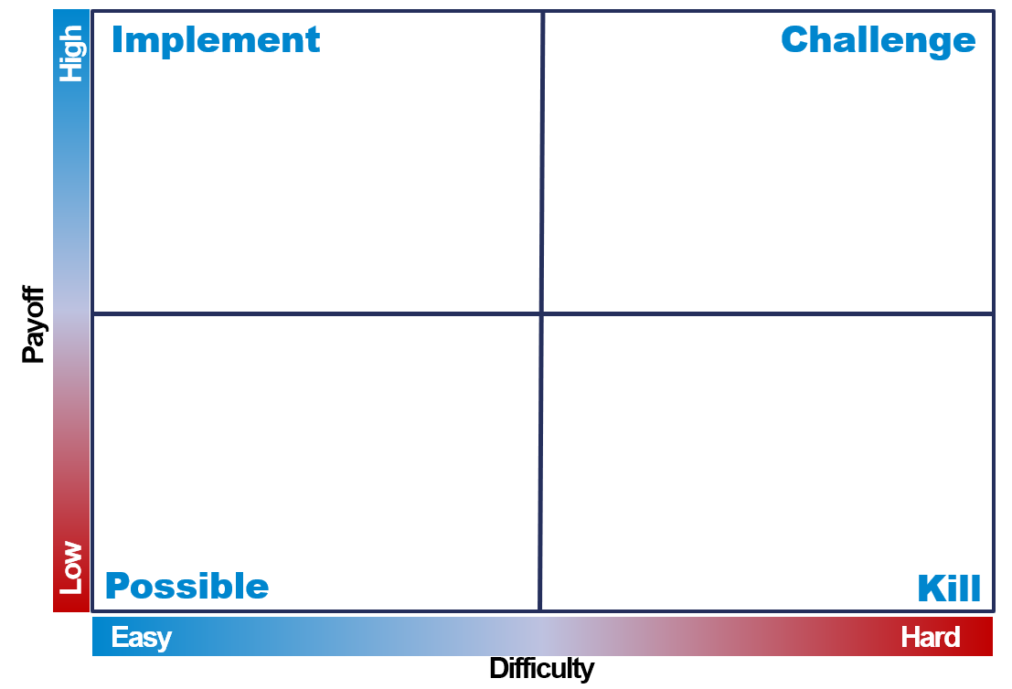

- The team should discuss each idea raised and determine which quadrant the idea should be placed in. Determine where each idea is placed on the PICK chart by considering the difficulty of implementing (easy to hard along the bottom) and the payoff level or impact (low to high along the side). Some factors to consider during this discussion include cost, time, staff availability, staff buy-in, leadership support, alignment with strategic goals, patient outcomes, patient satisfaction, available data, and sustainability. Your team may identify other factors to consider.

- The team should review and discuss the potential ideas in the four categories.
Possible – Low Payoff, easy to do – Useful for getting momentum behind improvements by immediately solving some simple problems. The risk is also low with these ideas, so little effort is wasted on them if they don’t work out.
Implement – High Payoff, easy to do – Where most of the effort should be focused,
Challenge – High Payoff, hard to do – Longer term projects that are good to do, but perhaps not right away.
Kill – Low Payoff, hard to do – These ideas should be set aside or redefined to fall into one of the other three categories.
The PICK Prioritization Matrix will typically yield 2-3 opportunities that stand out as the highest priorities in either the Implement or Challenge quadrants. Additional factors unique to each project will need to be considered to determine which one to choose first.
The questions below are for the team to consider in making that final choice.
- Are there existing standards or guidelines that can help with this initiative?
- Are there measures available to help monitor progress, or must we create them?
- Is this a topic that is publicly reported and, therefore, important to our organization’s image?
- What type of changes will be involved, what staff will be most effective, and what training needs will be needed?
- Do we have any champions for this initiative or anyone passionate about the topic?
- If we do work in this area, will it impact our organization in any other way?

To help with documentation, you can capture an image of your completed PICK chart, document your decisions in meeting notes, or transfer to a table format.

