SMARTIE Goals Worksheet
Goal setting is essential for any performance improvement. Setting goals helps you clarify your purpose, design your impact measurement, and focus your action planning. This worksheet is intended to help establish appropriate goals for performance improvement projects.

You may have heard of SMART goals in the past, but without an explicit equity and inclusion component, well-intentioned improvement goals may widen disparity gaps by leaving marginalized community members behind. For that reason, we are now using SMARTIE goals! SMARTIE stands for:

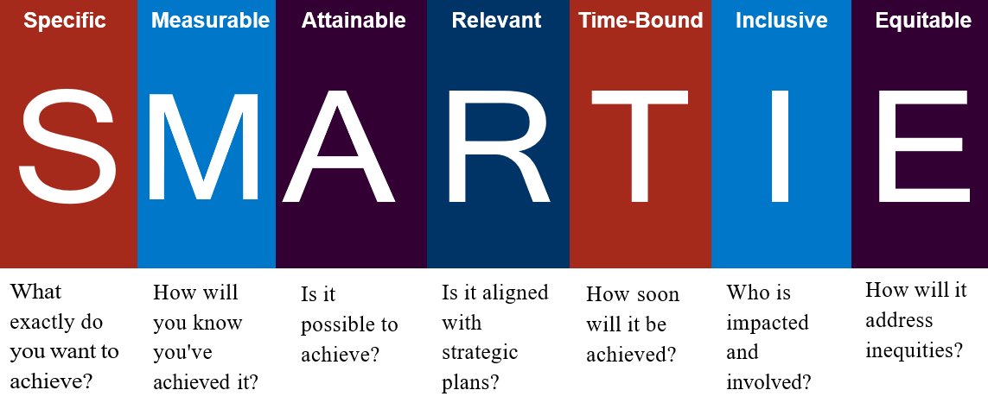
By incorporating inclusion and equity into your goals, you can ensure tangible and actionable steps demonstrate your organization’s commitment to inclusion and equity. These SMARTIE goals should be specific to your community and informed by your organization’s needs. SMARTIE goals are about including marginalized communities in a way that shares power and leads to more equitable outcomes.

Here’s an example of a goal turned into a SMARTIE goal:
Good  Goal | Better  SMART Goal | Best  SMARTIE Goal
We will reduce hospital-acquired infections. | We will reduce hospital-acquired CAUTI infections by 25% by December 2024. | Our infection control team will lead a project to reduce hospital-acquired CAUTI infections among female patients aged 65+ by 25% by December 31, 2024, as this group has the highest CAUTI rate in our hospital. This project will engage our geriatric and women’s health specialists, LTC and home health provider partners, and the community senior center.

Writing Your SMARTIE Goal
Use the spaces below to help you brainstorm and refine a SMARTIE goal.
What Specific strategic outcome are you trying to achieve? What problem or challenge will it solve?
What Measure(s) will you use? What data source(s) you will use? How and when will you know the project has been successful and/or is complete? How will you stratify data to check for current or new disparities?

What is your ambitious yet Attainable benchmark(s)? Is it impossible or unreasonable to attain and maintain? Is it set too low and not challenging enough?

How is this goal Relevant and related to our overall strategic improvement plan or current improvement priorities? Is this goal realistic, given our current resources?

Time-Bound: The timeline for this project is between (start date) through (end date)
How will you make this project Inclusive? Who will be affected within our organization? Who will be affected outside of our organization? How will you include impacted patients and/or groups in co-designing the goal and project? How might exclusion show up?

How will this project ensure that the impact and outcomes are Equitable? Is there the possibility of any unintentional disparate impact along the lines of power and/or identity? How else might inequity show up? For whom? How can you mitigate or eliminate disparate impact?

